**Introduction to Operating Systems**

An **operating system** has three main **functions**: (1) manage the computer's resources, such as the central processing unit, memory, disk drives, and printers, (2) establish a user interface, and (3) execute and provide services for applications software.

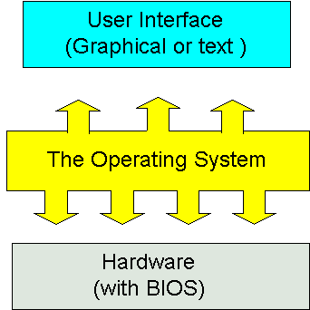

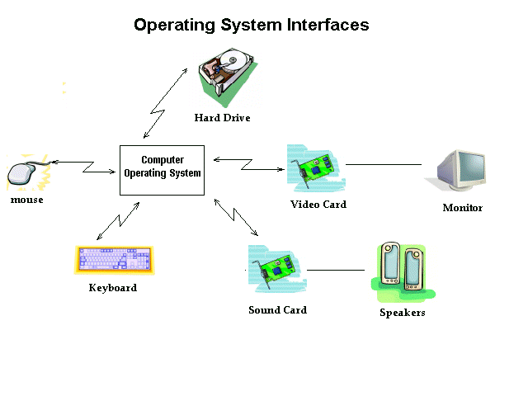

**Types of Operating Systems**

* Single- and multi-tasking
* Single- and multi-user
* Distributed
* Template
* Embedded
* Real-time
* Library

### Components

### Kernel

#### Program execution

#### Interrupts

#### Modes (Protected and Supervisor)

#### Memory management

#### Virtual memory

#### Multitasking

#### Disk access and file systems

#### Device drivers

### Networking

### Security

### User interface

[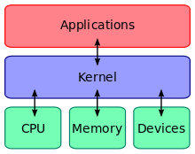](https://en.wikipedia.org/wiki/File:Kernel_Layout.svg) [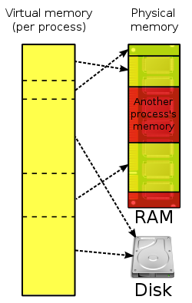](https://en.wikipedia.org/wiki/File:Virtual_memory.svg)

**Processes**

In computing, a **process** is an instance of a computer program that is being executed. It contains the program code and its current activity. Depending on the **operating system** (**OS**), a **process** may be made up of multiple threads of execution that execute instructions concurrently.

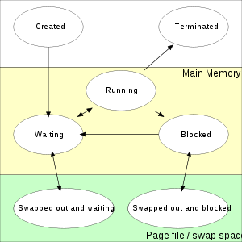

**Process management** is an integral part of any modern-day **operating system** (**OS**). The **OS** must allocate resources to **processes**, enable **processes** to share and exchange information, protect the resources of each **process** from other **processes** and enable synchronization among **processes**.

The **process scheduling** is the activity of the **process** manager that handles the removal of the running **process** from the CPU and the selection of another **process** on the basis of a particular strategy. **Process scheduling** is an essential part of a Multiprogramming **operating system**.

In **system** programming, an **interrupt** is a signal to the processor emitted by hardware or software indicating an event that needs immediate attention. An **interrupt** alerts the processor to a high-priority condition requiring the interruption of the current code the processor is executing.

